Note: Any paper with Lall in parentheses is a paper Dr. Lall assigned me this Tuesday. All the other papers are ones I found independently researching. These notes are divided into 3 sections: Formulations for Optimization of Drinking Water Networks, Packages/tools for Optimal Water Network Design, and Formulations for Optimization of Water Reuse And/Or Decentralized Networks. I highlighted the most useful papers/packages in every section. Please let me know if you have any questions.

### **Formulations for Optimization of Drinking Water Networks (1-5 are centralized networks):**

1. Boindala and Ostfeld, Robust Multi-Objective Design Optimization of Water

Distribution System under Uncertainty, 2022 (Lall)

* Multi-objective optimization for resiliency maximization and minimization of cost
  + Resilience defined by resiliency index
  + According to this paper previous studies did the same thing, but they assumed the parameters are deterministics which created designs that did not meet real life performance standards
  + This paper claims they did not account for uncertainty in design parameters
  + There has been stochastic optimization methods used to solve least-cost design and multi-objective design problems (the second objective usually being robustness or reliability)
    - However, they have heavy computational time and there is a lot of uncertainty in their probability density function assumptions so practical application is limited
    - Robust optimization has been used to solve least cost design problems under uncertainty under different loading conditions
    - **This paper will use the non-probabilistic (like robust optimization) optimization techniques to solve a multi-objective problem with demand uncertainty**
* Medium to Large water distribution systems (it assumes centralized systems)
* Assumes ellipsoidal uncertainty set
  + Restricts all parameters from obtaining their worst case values at the same time
* The Water Distribution System Design
  + Surrogate measures for reliability
    - Entropy-Based
      * Redundancy, multiple flow paths, flow uniformity
    - Power/Energy-Based
      * Most explored
      * Total energy supplied to the system by sources and pumps to determine resistance to pipe failure
      * Ensures less energy is dissipated from friction, enabling higher energy available at demand nodes
      * One method is the energy efficiency index: ratio of energy of water supplied to consumers to total energy entering the water distribution system from sources, tanks, and pumps
        + 4 indices:

Reliability: average computed energy efficiency over different failure scenarios

Vulnerability: minimum energy efficiency in various failures

Resilience: average energy efficiency during recovery after failure

Connectivity: minimum percentage of delivered water to consumers during different failure scenarios

* + - Other
      * Maintaining system pressure and flow velocities within specific limits
* In this study resilience metric index is their second objective function
* Their formulation:
  + 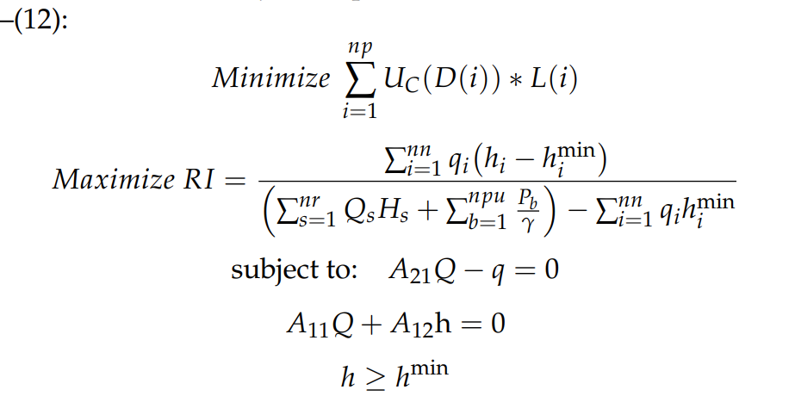
  + Cost per unit length of pipe (Uc) corresponding to a given diameter, times the diameter and the length for the minimization function (np is number of pipes)
  + For the resilience function (RI) it is the difference in head between the minimum allowable head (himin) and the head of a given node (hi) times the demand of that node (qi) for each node (nn) over the sum of the flow of the reservoir (Qs) times the head of the reservoir (Hs) for each reservoir plus the pump energy (Pb) divided by the pump efficiency (gamma) of all the pumps (npu) minus the minimum head times the node demand (qi)
  + Constraints:
    - All head has to be greater than minimum head
    - A21 = A12t is the connectivity matrix of the network, and Q is the flow of each pipe
      * So basically A21Q - q = 0 is saying that you need to meet each node demand exactly
    - A11 = nonlinear frictional resistance of pipe
      * So A11Q + A12h = 0, is saying that your frictional resistance against the flow needs to match the frictional head loss at each point
      * Which can be represented with the Hazen-Williams head loss equation analytically:
      * 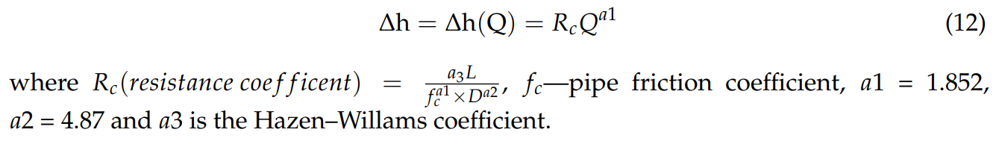
* In this paper the Q values are uncertain so that is where robust optimization formulations are applied for optimal designs under uncertainty
  + Uses a linear surrogate model to replace the head loss function above
  + This turns the resilience function into the following:
    - 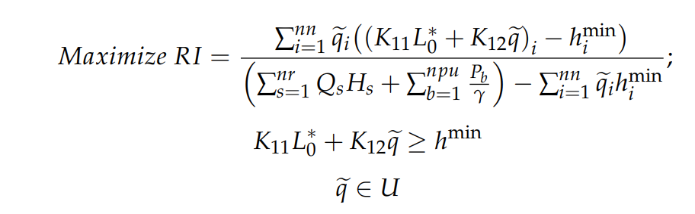
    - It would take too long to explain this in depth but basically the Ks are coefficients for a linear function in the form of y = mx + b, where your y is basically the head at a given node
* Used cuckoo’s nest for a self-adaptive multi-objective algorithm
  + Basically initializes algorithm parameters and generates populations using uniform random distribution, and stores corresponding objective function values. They determine the best population (nest) based on the pareto font and the highest crowding distance. They then generate new nests using Levy flight random walk and they keep updating the nest until they reach the termination time decided by the user
* Results
  + Hanoi case study (medium size)
  + Around a third of the nodes were assumed to be certain, and the other two thirds had uncertainty deviations of 12% from the mean of each region
  + Single source with head of 100 meters (minimum pressure head at every node is 30 meters), 6 pipe sizes, 32 demand nodes, 34 pipes
  + Large network case study
  + All demand nodes are uncertain, removes the two pumping stations, 52 nodes, and 65 pipes, minimum pressure head of 30 meters in addition to node elevation, 11 different pipe sizes, c = 130 (hazen williams)
  + All demands are uncertain but mean demands are assumed to be base demands in a different paper
* Conclusion:
  + This paper looked into apply robust optimization for multi-objective optimization techniques to solve a water distribution design problem with uncertain demands
  + Uncertainty in demand is higher for networks with inherently low topological resilience compared to higher topological resilience networks

1. Eiger, Shamir, and Ben-Tal. Optimal Design of Water Distribution Networks. 1994. (Lall)

* Only focuses on design not design and layout
* Difficulty: discrete elements, nonlinear and nonconvex problem, and high dimensionality
* Approach: global search, tight lower bound, nonsmooth algorithm for minimization, dual problem paired with original problem using Lagrangian duality
  + Dual problem is a semi-infinite linear problem
    - Linear objective function and infinitely many linear constraints
    - The dual is equivalent to a finite linear problem
  + Branch and bound algorithm solves the problem when a solution within the tolerance bound is found
* Network of pipes only with no pumps, valves, or boosters
* Basic formulation considering flow in network links, flow continuity, pipe lengths, physical constraints from energy conservation, and pipe costs
* Hazen Williams for head loss
  + Evaluated over basic loops (minimal set of loops that all other loops can be represented as a linear combination of them)
  + Basically the hydraulic energy loss on the ith basic loop is equal to the head difference between its end (the head difference is 0 for closed loops)
  + There is also the minimum loss of hydraulic energy over each path as a given constraint
* The final loop constraint basically just ensures the segments within the loop add up to the total length of the loop (basically a one size for every pipe type of constraint)
* Adjacency matrix:
  + Rij = 1 means link j directed toward i
  + Rij = -1 means i directed towards j
  + Rij = 0 means does not exist
* Assumes a certain water demand at each node wi s.t. R*q = w, where qmin and qmax a determined heuristically
* Borken up into an inner problem that can be solved by linear programing code and an objective outer function that can be non smooth. Both problems are non convex
* Langrangian duality for lower bound of the global optimum search, this can be simplified into a finite-constrained linear problem
* Affine transformations reduces the problem dimensionality
* The method performed well and quickly for their hypothetical problems, we can explore this for simplifying larger problems for our optimization problem potentially but I do not see a direct application at the moment
* At that time before you had the computing power to deal with nonlinear nonconvex problems this paper was super important, but now we have the computing power to do that
* The formulation also is not particularly useful in my opinion because it is very basic

1. Ostfeld and Shamir, Design of Optimal Reliable Multi Quality, 1996. (Lall)

* Uses the same methodology of breaking up into an inner and outer problem
  + The outer nonconvex nonsmooth problem is for circular flows
  + The inner convex problem is quadratic
* This time it integrates optimal design and reliability
  + Reliability in this case is the ability to maintain desired performance levels under certain failure scenarios like a single random component failure
  + Applied to system of 33 pipes, five pumps, and 16 nodes (two source does with treatment facilities and 14 demand nodes)
  + Single loading condition and one quality parameter
* Note: at this time reliability analysis was not a thing yet (as long as you designed it up to code you were good), this was one of the first attempts to quantify reliability
* Focuses on the design phase only not layout
* Resilence methodology:
  + Redundancy
  + Additional hydraulic capacity
* Methodology
  + Formulation of optimization model that limits cost under various demand patterns (loadings), with constraints of continuous flow and energy, pressure head at node constraints, length of each pipeline (where pipelines are broken into segments), power of pumping stations, and threshold concentrations at consumption nodes (water quality)
    - Decision variables are vector of flows in pipes for each loading condition, pumping heads for pumping station and loading condition, pipe segment lengths, max power of each pump station, and treatment facility capacity/removal ratio
  + Identification of backup subsystems maintaining service levels when failure occurs
    - Backup defined as subset of links in the full system
    - Analysis restricted to single link failures requiring two backups
  + Hydraulic laws and consumer demands formulated separately for each backup and loading condition
  + Models for backups added to the model of the complete system and optimization model is solved
* Tradeoff between cost and reliability of backups
  + Backups needs to give 1. Proper reliability 2. Is cost competitive to other sets of backups
* Note: At this point in time there was no quantitative model for a good system layout
* Two backups are defined as such:
  + Set of nodes for each of backups equals the set of system nodes
  + Union of the set of arcs of two backups equals the set of system arcs
  + Each of the backups is a connected graph
  + Number of common arcs of two backups is minimal
* Backups are found by searching for two spanning trees in a system whose distance is maximum. The distance between two trees is the number of arcs in one tree but not the other (algorithm: kameda)--> reliability is tested by changing customer requirements
* For the mathematical formulation two problems: a QH (linear programing problem) and a QC (quadratic convex)
* P1 QH model
  + Similar to the previous paper each node i, j is represented by a +1, -1, or 0 to indicate j to i, i to j, or non existing arcs respectively
  + They also have a constraint for maximum allowable head loss
  + The sum of pipe segments alone a link must equal the total link length
  + Least cost model for pumps and pipes
  + Continuity of energy constraints within loops where the pumping station needs to match the loop head differences
  + Headloss with hazen williams for the hydraulic gradient
* P1-QC Model
  + The least cost model for O&M and treatment aspects
  + Constraints on allowable concentrations of contaminates at internal nodes for steady state quality conditions
  + Restriction of removal ratios for the treatment facility
  + Restrictions on the maximum removal ratio of the treatment facility
  + Minimize the cost of purchasing water at sources plus treatment cost for capital and O&M
  + Cost of purchasing water: 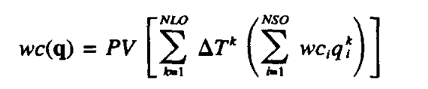
    - Tk is the duration of loading condition k in a year, PV is present value factor, wc is cost of water at the source, qi is discharge at facility i with loading condition k
  + Capital cost: 
    - TCC is construction cost of treatment facility, determined from cost data Z per m^3 of treated water, based on flow distribution q, and a removal max ratio (RRmax), and gamma*q the construction treatment cost coefficient for given flow q
  + Total cost of operation: 
    - Alpha is treatment cost coefficient at facility, RRik is removal ratio for loading condition k and facility i, beta i,k is the operation cost coefficient
* Model properties
  + Inner problem convex, optimal value function nonconex and nonsmooth, outer problem has less dimensions than smaller one, solution of inner problem is a global minimum, feasible solution of P1-QC model because we assume maximum removal ratio of 100%, final solution is a local minimum
  + We take the gradient of the langrangian of the P1 formulation with respect q with a feasible flow distribution in the pipes, optimal prime values of the decision variables for the P1-QH and PQ-QC models, and optimal dual values of the decision variables of those same two models
  + Reduction in the dimension of outer problems can be achieved by using circular flows

1. Caballero and Ravagnani, Water Distribution Networks Optimization Considering Unknown Flow Directions and Pipe diameters. 2019 (lall)

* MINLP model to create a water distribution network without knowing the direction of flow
  + Was able to calculate correct directions for case studies and pressure drops and velocities for two existing case studies
  + Usually pipe flows and directions are defined before hand
* Global optimization techniques usually not used to solve these problems because nonlinear and nonconvex
* Pressurized hydraulic loops also increase the complexity of these problems
  + Hazen Williams for looped network: 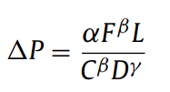
    - Delta P = pressure drop, F is volumetric flow rate, L is pipe length, D is diameter, C is the coefficient for rugosity, and alpha/beta/gamma are constants corresponding to the system of measurement
  + This leads to complex nonlinear problems, but nowadays we can solve them using special software instead of adding it to the optimization
* Literature
  + References Shamir
  + Discusses the transition into MINLP
  + Also discussed how the majority of solvers are using non deterministic approaches in genetic algorithms or meta-heuristic approaches (ant-colony optimization, particle swarm, simulated annealing, etc.)
* In this paper MINLP optimization model is used without using additional software for hydraulic calculations and considering flow directions as optimization variables
* Distance between nodes and elevation of nodes are fixed
* Given set of reservoirs and demand nodes
* Loops are possible, and cost must be minimized
* Optimization variables are: node pressure, pipe velocity, and diameter
* Hazen williams for hydraulic calculations and pressure in nodes and fluid velocity must obey minimum limit
* Pumps can be placed but this model will go with gravity whenever possible
* Set up of the model:
  + Variables:
  + 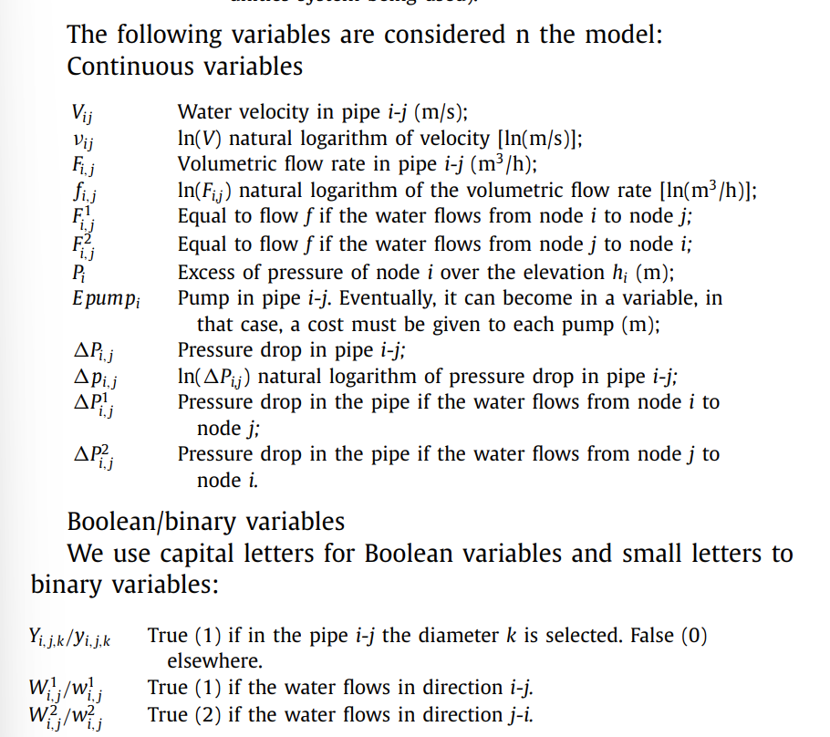
  + Mass balance for each node:
  + 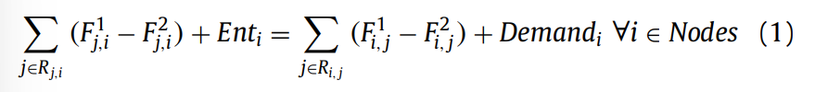
    - 1 indicated in the direction indicated under R, 2 indicated the opposite direction
  + Velocity of pipe: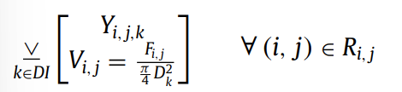 which is simplified to this using logs→ 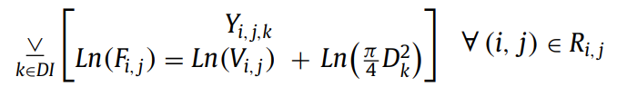
  + Difference of pressure of two nodes: 
    - 1 is i to j, and 2 is j to i (these are not exponents)
    - Delta P is the pressure drop which is calculated using Hazen Williams: 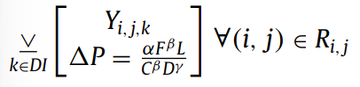 this is also simplified using logs to this 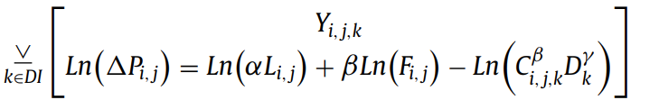
  + Constraint to force the flows and pressure drops to be a non zero value
  + 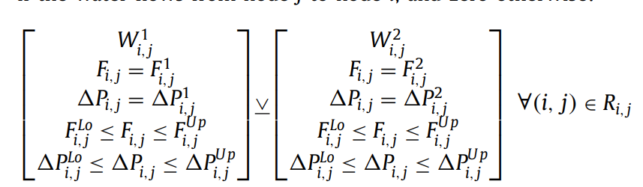, basically these are binary variables so if we do they must take on a value
  + Cost of a pipe constraint: 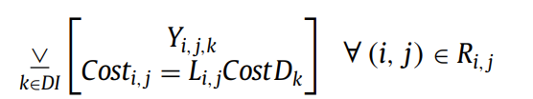
  + Cost is the minimized objective
  + The reformulation with logs:
    - 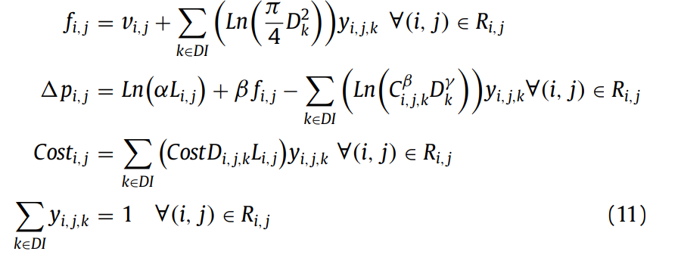
  + Reformulation of the disjunction:
    - 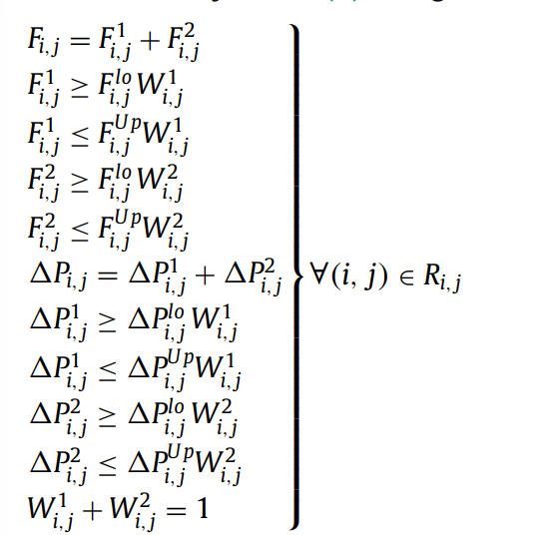
  + To relate F with f and delta P with delta p they add two constraints setting the exp(lower case variable) = upper case variable
* Summary of Model:
  + 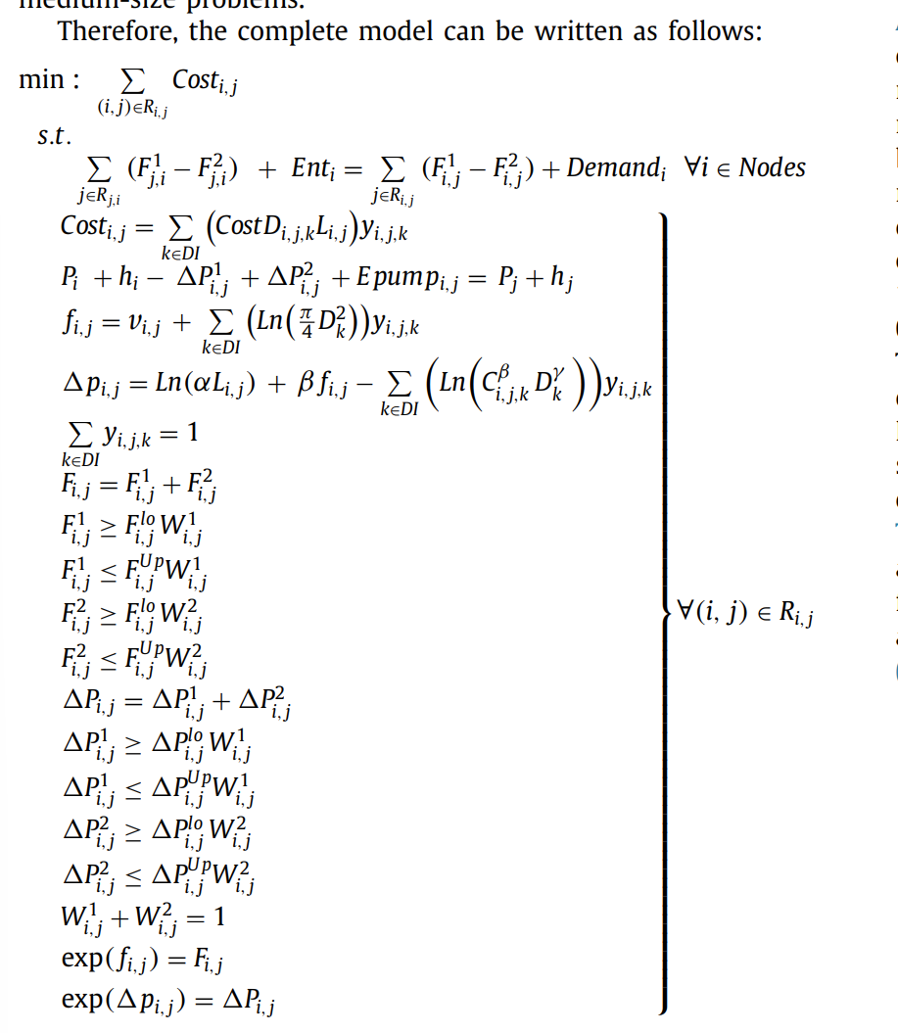
* According to the results the addition of pumps were not an issue for this model
* They were able to use global optimization solver BARON in GAMS
* They were able to linearize non linear equations
* The two exponential equations are bounded
* Also successfully avoided the use of additional software for hydraulic equations

1. Monsef, et. all. Comparison of evolutionary multi objective optimization algorithms in optimum design of water distribution network. 2018 (Lall)

* This paper looks at the Non dominated sorting genetic algorithm (NSGA-II), Multi objective differential evolution (MODE), and Multi-objective particle swarm optimization (MOPSO) multi-objective optimization methods, comparing them for accuracy, convergence rapidity, and solution diversity for the design of distributed water networks
* Evolutionary algorithms are attractive for multi-objective analysis with classical methods
  + Begins with a set of solutions which are randomly generated and called the initial populations
  + Following populations are generated by some operators like mutation, crossover, and selection
  + NSGA-II
    - Non-dominated sorting, density estimation, and crowded comparison
    - Non dominated sorting retains members that are not dominated, once you are dominated you get removed (even if parent generation
    - Density of a member is the distance of the point and two members of its neighboors
    - Crowded comparison operator aims to increase the diversity of the pareto front. Population members are ranked taking into account seniority and local crowding distance
  + MODE
    - Mutation equation with three sets of vectors, all randomly chosen derived from parent set z
    - The mutant vector and F is a real constant factor between 0-2 known as a scaling factor
    - Non dominated population is selected based off ranking and crowding distance
  + MOPSO
    - Stochastic population based EA based on birds and swarm intelligence
    - Will move towards the optimal solution with regular velocity
      * The speed is composed of three components: velocity of previous generation, the distance to the best position of the same particle of past generations, and the distance to the position of the leader particle
      * The leader is the particle with the best performance in the optimization procedure
    - Position is updated each generation
* Objectives:
  + Cost
  + Reliability
    - Hydraulic reliability (demand change)
    - Mechanical reliability (tolerance against physical changes like pipe failure)
    - Network resilience (NR)
      * Considers surplus hydraulic power as a proportion of available hydraulic power, considering the number of inlet and outlet pipes in each demand node
      * Continuous between 0 and 1
      * 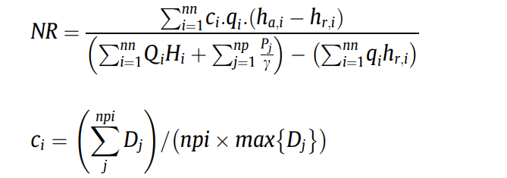
      * Nn is the number of demand and supply nodes, np the number of pumps, ci the uniformity of connected pipe to node, ihai available head at supply node in kPa, hri is required head kpa, qi is demand at node i (m^3/s), Qi is supply at input node, Hi is head, Pi is power from pump (kw), gamma is specific water of water, npi is number of pipes, and Dj is diameter. Tanks act as demand nodes when they are filling and reservoirs when emptying
* EPANET 2 software was the hydraulic solver
* In all cases MODE was faster and covered a wider range of solutions

1. Schwartz, et. al. Least-Cost Robust Design Optimization of Water Distribution Systems under Multiple Loading. 2016.

* This paper is similar to the previous work of Ostfeld. It looks to use robust design to deal with uncertain water demand at various nodes. The problem will size pumps, pipes, and storage. It will also place pumps. It assumes an existing layout for pipes.
* Like Paper number 1 in the notes it also uses an ellipsoidal uncertainty set
* It is a minimum cost objective that considers the tradeoff between O&M (represented primarily as energy costs) vs capital costs
  + Sub Objectives: pipe capital cost, tank capital costs, pump station capital costs, and energy costs for pumping
  + They incorporate uncertainty to this sub objectives and constraints using a K matrix for node demand (q) similar to paper 1
* If we want to explore adding uncertainty in node demand into our model I think we could use the formulation from this paper because it maintains a computation time which is suitable for our needs. If our goals change, such that we want to add reliability to our optimization we can just go with paper 1
* Effectively this is just the first paper except we are only designing for a minimum cost objective.

1. Zheng et. al. A combined NLP-differential evolution algorithm approach for the optimization of looped water distribution systems. 2011.

* Two step process in which layout is creating with a minimum spanning tree and then sized with an NLP optimization model with a DE solver
* Used for multi source water distribution systems so we can easily take this application and apply it to a decentralized network
* Three steps:
  + Shortest distance tree within an existing looped network using Dijkstra’s algorithm
  + NLP for diameters in the shortest tree layout
  + Original looped layout optimized using differential evolutionary algorithm like in step 2 (with NLP)
* The NLP only considers the pipe size and length for cost
  + Because we are doing this for a shortest distance tree we can exactly calculate the flow rates for each arc
  + Additionally no energy balance is needed because we do not have any loops in the tree
  + We only need consider maximum and minimum head at each node, hazen williams friction loss, and diameter min/max as our constraints
  + This means the system does not consider pumps and only assumes gravity flow
  + Diameter solutions are continuous
  + Also assumes minimum pipe diameter for alternative pipes (arcs not part of the minimum spanning tree)
* Differential Evolutionary algorithm is used in step 3 to get optimal sizes for the pipes within commercially available sizes
* Overall this methodology seems too simple for us to apply in our designs
* But we can use this paper as a justification for using the minimum spanning tree algorithm for our layouts within road networks

### **Packages for Optimal Water Network Design:**

1. Zhang et. al. Wastewater reuse and energy saving require a more decentralized urban wastewater system? Evidence from multi-objective optimal design at the city scale. 2023.

* Explores the use of the Sustainable Urban Wastewater System Generator (SUWStor) tool for finding the optimal degree of decentralization for wastewater treatment within a given area.
* Multiobjective where you can optimize for capital cost, energy consumption (O&M), and water reuse capacity
  + Capital Cost Objective: 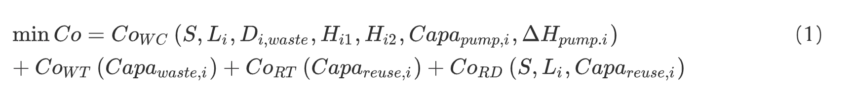
    - Cowc is wastewater collection, Cowt is wastewater treatment, Cort is water reuse, and Cord is water reuse distribution
  + Energy Objective: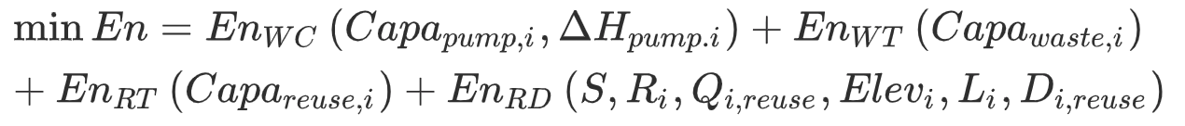
    - Enwc is wastewater collection energy, Enwt is wastewater treatment energy, EnRt is reuse treatment energy, and Enrd is reuse distribution energy
  + Reuse Objective: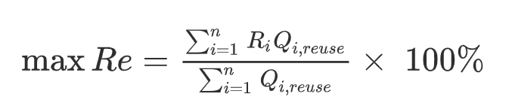
    - This is just the amount of wastewater that is reused divided by the amount of wastewater than can be reused
* The input into this network is a network of nodes and arcs
  + The arcs can be roads but don’t necessarily have to
  + You need to have at least one node(s) that produce(s) water and generate(s) wastewater (water treatment plant, drinking water, and houses that produce wastewater)
  + You also need the elevation of each node
* The tool will choose your wastewater treatment plant locations for you, which arcs will supply reclaimed (reused) water, pump capacity/placement, and sewer depth
  + The pumps are only for reclaimed water (reused water), which is distributed by a pressurized system
  + Wastewater is collected by a gravity flow system, but the objective function has a pump capacity variable so it makes me think they use lift stations like we do
* The constraints are: water balance, area restrictions for the potential wwtps, network topology (each node needs to be connected to a treatment plant), and hydraulic constraints
* Limitation: Unable to factor in onsite treatment because cannot estimate the energy demands and capital costs efficiently
* Coefficient of objective functions for cost will wildly change the answers
* It also fails to consider different decentralized wastewater treatment technologies
* Case study for a large city took 17 hours to run
* **In my opinion these researchers have done work that is very similar to ours. If we can get how they integrated their reuse costs with their wastewater collection costs I think we will be in a good spot.**
* **We can download their model off** [**github**](https://github.com/dzh-zhang/SUWStor) **and see what we can do with it**
* Uses ant colony optimization

1. Kaavada, et. al. Spatial optimization for decentralized non-potable water reuse. 2018.

* I looked at this paper previously, and I think it is good just to keep it in mind as we go forward with this project
* Platform for non potable reuse based on building size, topography, and economies of scale
* Comparison for capital cost, energy efficiency, and greenhouse gas emissions
* Only water reuse application in this study is toilet flushing
* Assumes demand is 50% of total wastewater production (works only for urban areas with mixed demand)
* Estimates piping to deliver the water to all bathrooms within a given building based on the building size
* Uses MST to connect all the buildings in the network
* Calculates total piping within the building based on number of floors
* Then finally calculates the diameter
* Work Flow:
  + 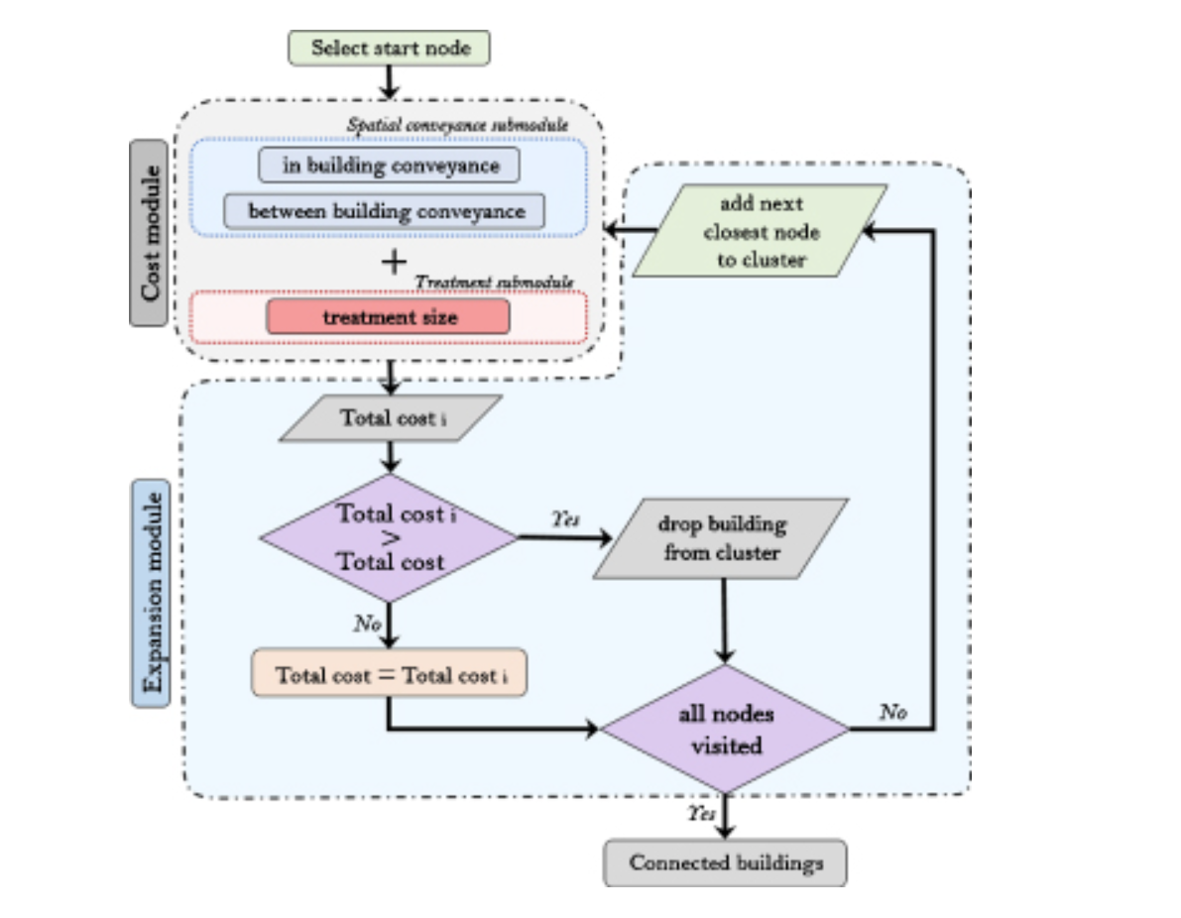
  + Interesting part is they have an expansion module to simulate future development and scale at which we would need to size this decentralized network
  + Outputs optimal clustering
  + In the city of SF they are able to identify which areas can benefit from reuse and which areas would not in terms of the three criteria we mention earlier
* For some reason the webtool was taken offline, so we would need to contact the research team to see how it works

1. Calle et. al. Optimal design of water reuse networks in cities through decision support tool development and testing. March 2023.

* Open source data, graph theory, and greedy optimization algorithms to evaluate the potential of water reuse in cities
* Maximum amount of people served per unit of invested cost, pipe lengths and diameters, location and size of storage tanks
* Inputs: Slope, elevation, building characteristics (and building location), and water consumption rates
* REWATnet is a semi-manual tool so might be difficult for regular operators to use
* Flow Diagram:
  + 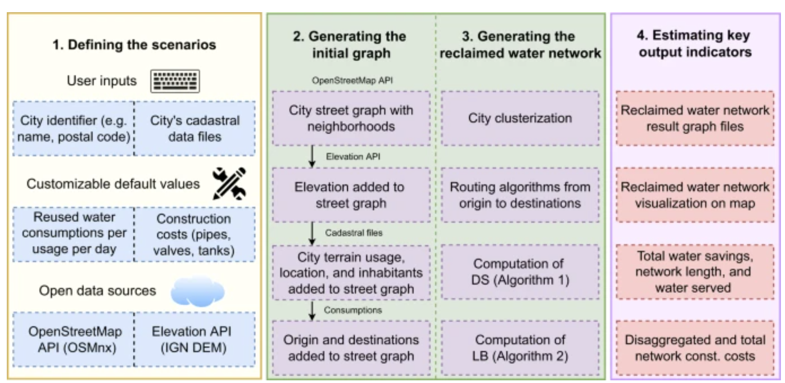
  + 5x5 meter precision for the DEM (in spain they have that data apparently)
  + Spain also has open source building use data in “cadastral files”
  + Optionally you can also add how much reused water you want and what uses of reclaimed water exist
    - This data is also useful for identifying where you want to put water reuse plants
* **This tool only considers existing centralized treatment plants as sources for water reuse and additional nodes that the user needs to define based on cadastral files**
* Pipe layouts designed by steiner tree algorithm
* Overall this tool is interesting, but it is a little unclear how they are dealing with head demands (I assume storage tanks but I am not sure), the clusters are defined by the number of reclamation points specified by the user, and if it considers O&M costs
* We need to request the code from the author if we want a deeper look into what is going on
* They do not provide optimization equations also which is a bit confusing
* Also there is no consideration of the wastewater collection network just the water reuse distribution network

### **Optimization Formulation of Water Reuse and/or Decentralized Networks:**

1. Liu, et. al. Energy-Optimal Siting of Decentralized Water Recycling Systems (DWRS). 2021. (Lall)

* Marginal Energy Intensity (MEI): location-specific energy footprint of centralized water supply vs decentralized energy footprint
* 5.3% higher in energy than current centralized supply, but with optimal siting the total system energy demand can actually be reduced by 0.77%, however if the dwrs are placed randomly or in the least optimal MEI locations you can increase overall energy demand by 0.65% and 2% respectively
* Known configuration/layout
* Compares three different distributed water reuse system deployment strategies
  + Study demonstrates the strategy will affect the energy tradeoffs
  + Flow backtracking algorithm will calculate MEI values
* Methodology
  + Reduction in water consumption is multiplied by the MEI value for savings (the amount of energy you would have had to use to draw the water instead from a centralized system)
  + They use supply and demand profiles as proxies instead of simulating for period of 15 minutes
  + They replace the most energy intensive location for centralized supply with DWRS
  + 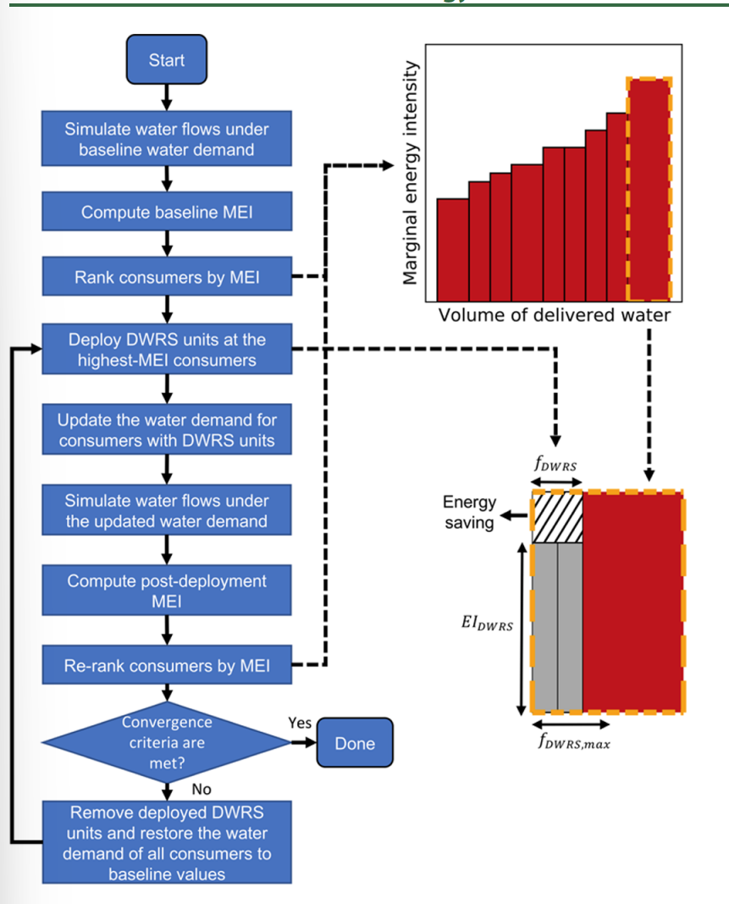
  + Consumer average water demand > smallest capacity of DWRS
  + Assumes DWRS operates at its full capacity once deployed to account for capital costs
  + Proposed framework has maximum upper bound fraction for the available water for non-potable water reuse applications (fdwrsmax)
  + Optimization Equations:
    - 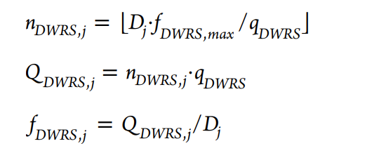
    - Ndwrs is the number of DWRS (integer), Dj is average daily demand from centralized location before, qdwrs is the daily capacity of one DWRS,
  + Divergence criterion is when Ki-1 = Ki, which can be relaxed to be for 95% of locations are preserved in the next iteration
  + Greywater recycling
  + Objective function:
  + 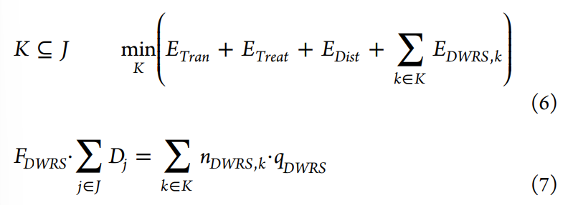
* Does not consider change in pipe size and other distribution requirements outside of pumping
* Replaced 10% of water demand with distributed water networks
* Only greywater recycling, which assumes 1kWh/m^3 EI and a daily capacity of 1 m^3/day, and fdwrs = 30%
* They assume that transmission and treatment components are uniform which is false in real life and should be adjusted if we want to apply this methodology in practice
* High-MEI locations remain high MEI even after the DWRS deployment which validates the robustness of this methodology
* Argues even with multiple sources this method would work more or less similarly but you have to specify the fraction of total water demand met by each source and ensure the operating schedule maintains this

1. Putra and Amminudin. Two-Step Optimization Approach for Design of A Total Water System. 2008.

* Looks into optimizing the placement of decentralized wastewater treatment units and water reuse at various outlets within an existing system
* It determine which areas to place a reuse unit based on pipe network complexity and the concentration of certain contaminants for discharge
* It considers the reduction of contaminate treatment cost for their decentralized wastewater network layouts
* There is no discussion of pipes, pumps, and/or nodal head requirements
* This is more of a master planing tool than a system design tool for individual water reuse system components
* **It might be worth considering how we could use this for cities with existing wastewater treatment systems as oppose to our current model which looks just at building systems from scratch**

1. Ko and Choi. Development of a Multi-Objective Optimal Design Approach for Combined Water Systems. 2023.

* Optimal design for combining water distribution networks with urban drainage systems and water reuse systems.
* Combines EPANET and SWMM for hydraulic analysis
* Considers rainwater and sewer storm water as water sources in SWMM and river water as sources in EPANET
  + End Uses: Toilet flushing, river restoration, irrigation
  + Rainwater storage tanks were used to estimate capacity of water reuse systems
  + Assumes 30% of water demand is non potable in Korea
* They did a single objective optimization to have the minimum cost of water reuse, urban drainage, and water distribution
  + They installed dummy nodes to provide water to the system when the rainwater storage tanks (the water reuse systems) had exhausted capacity
* Overall Design Flow chart:
  + 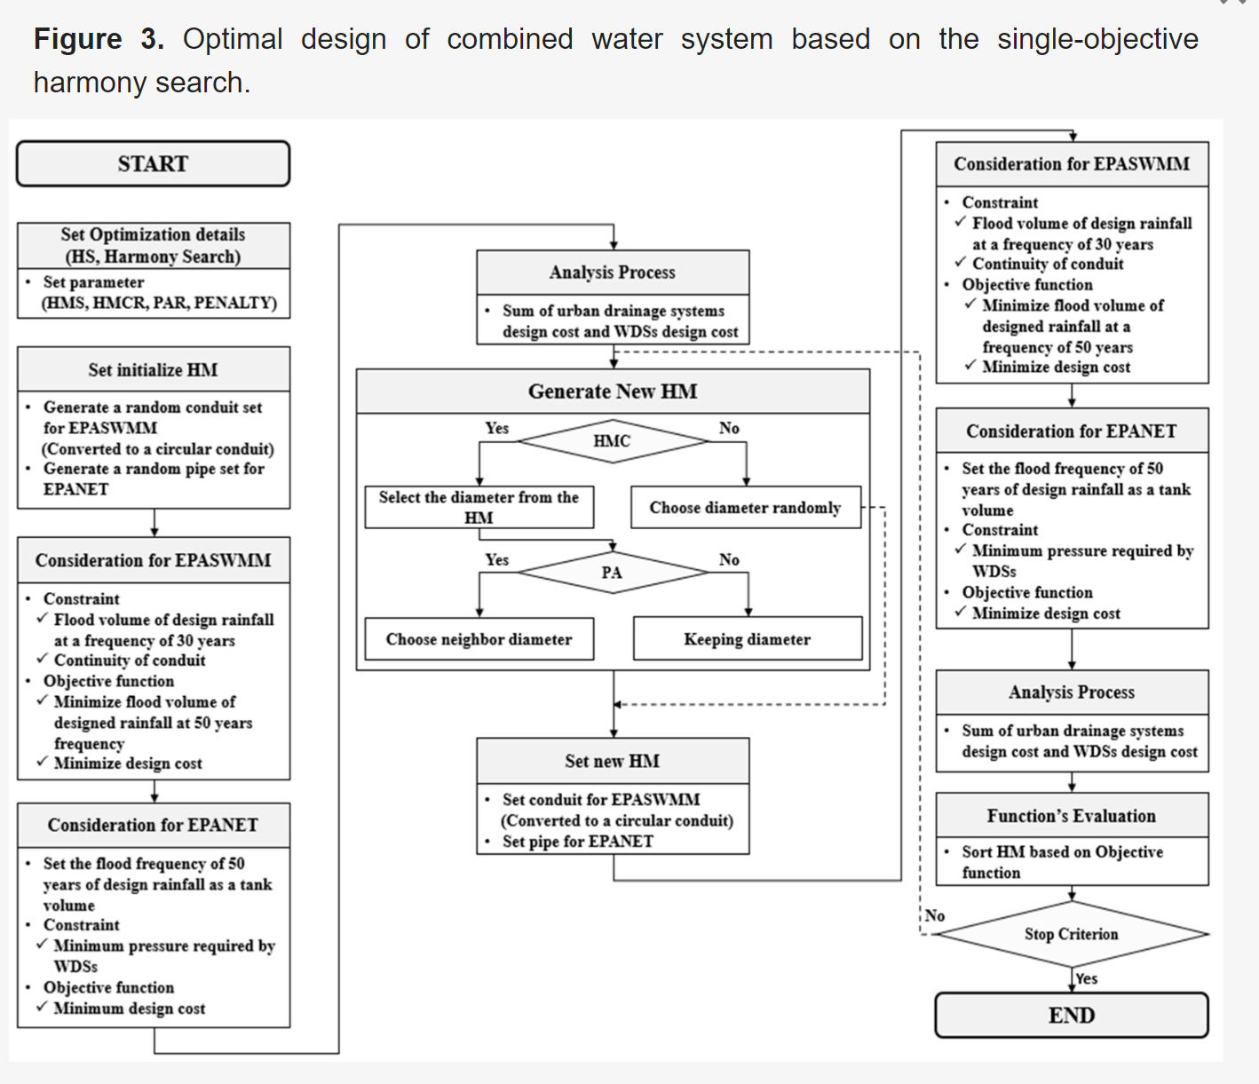
  + They also did a multi objective function that tried to minimize flooding but for these notes I ignore this
* Two issues:
  + 1. The cost function is too simple it only considers pipe cost
  + 2. It is unclear how head constraints at each node are being meant
* Overall, the optimization itself needs work but I think this paper could serve as guidance for us to integrate the EPANET and SWMM softwares to help estimate the capacity of pipes for water distribution and water reuse networks